**CSCE 5150 Analysis of Computer Algorithms**

**Assignment 7**

**Uday Bhaskar Valapadasu**

**11696364**

State your answers legibly and concisely. Your solutions will be graded on correctness, elegance, clarity, and originality. Please remember that although group work is permitted, the work handed in must be in your own words.

Design a backtracking algorithm that inputs a natural number 𝑛, and outputs all the groups of ASCENDING positive numbers can be summed to give 𝑛. Pseudocode is sufficient. An implementation of this algorithm is not necessary.

For example, if 𝑛 = 6, the output should be

6

1+5

2+4

1+2+3

and if 𝑛 = 10, the output should be

10

1+9

2+8

3+7

1+2+7

4+6

1+3+6

1+4+5

2+3+5

1+2+3+4

Hint: Store the terms of the current group of ascending positive numbers in an array 𝐴[1. . 𝑛]. Backtrack through all possibilities using a variant of the generalized string algorithm in which term 𝐴[𝑖] cycles through all values from 𝐴[𝑖 + 1] − 1 to 1.

**Pseudocode: Ascending Sum Parts**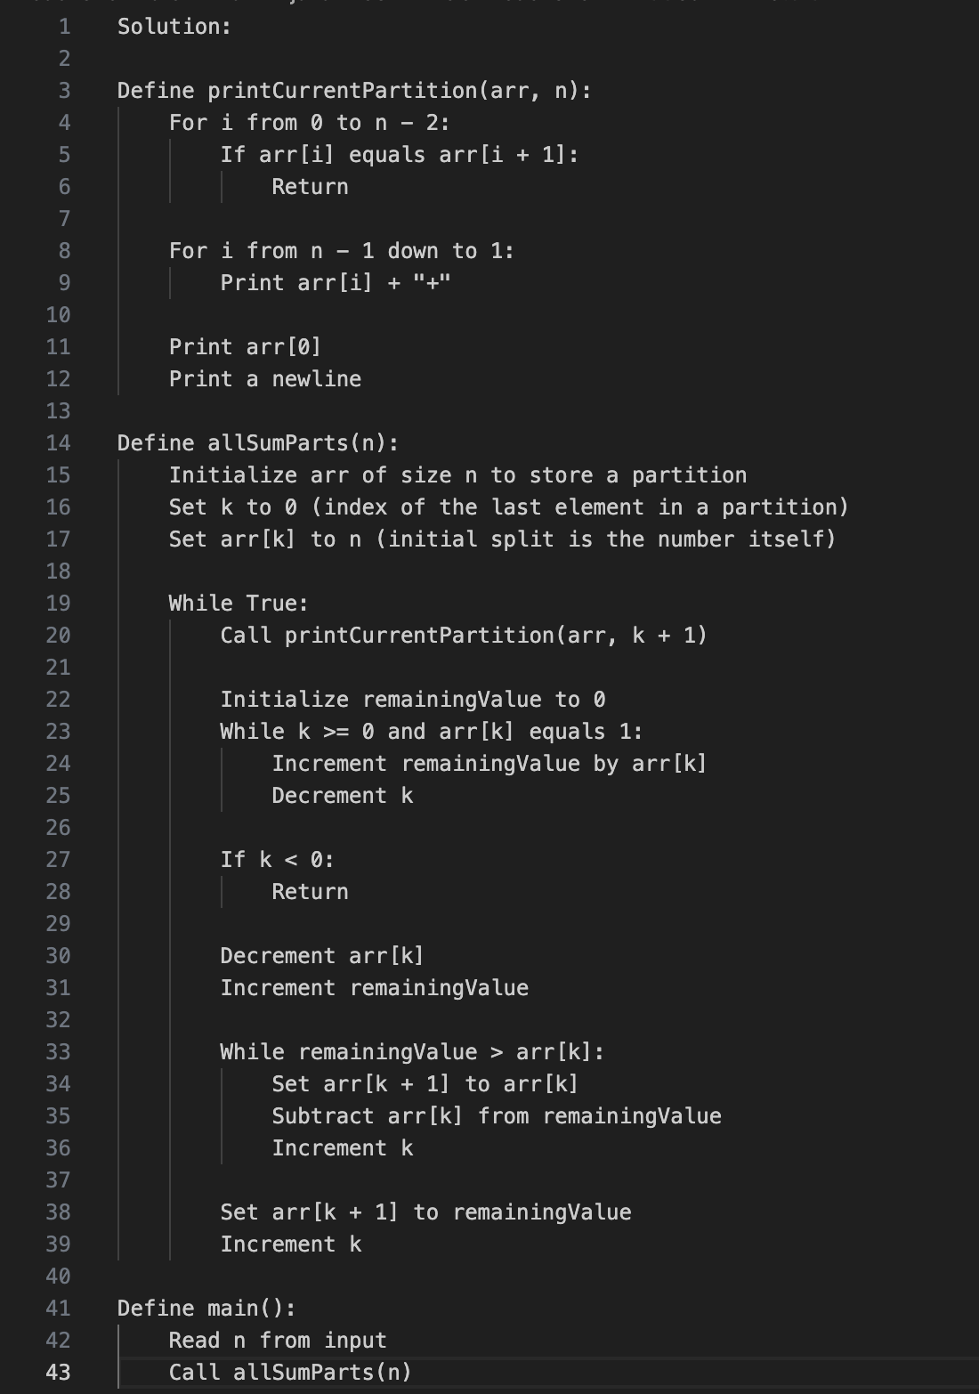

**Implementation in JAVA**

**Output:**

